B.Sc. DEGREE EXAMINATION, NOVEMBER 2015.
II YEAR — IV SEMESTER
Major Paper IV — ELECTRICITY AND ELECTRO MAGNETISM
Time : 3 hours Max. marks : 75
SECTION A — (10 × 2 = 20 marks)
Answer any TEN questions.
1. State Thevenin’s theorem.
2. Define the time constant of a CR circuit.
3. Define peak, mean and rms values of a.c. voltage.
4. What is delta connection? Give its representation?
5. What are the causes of earth’s magnetic field?
6. What is magnetic permeability?
7. State Biot-Savart’s law.
8. State Faraday’s law of electromagnetic induction
9. Define mutual inductance and the coefficient of coupling between two coils.
10. Give the condition for the moving coil galvanometer to be ballistic.
11. What is meant by power factor of an a.c. circuit?
12. Define self inductance.
SECTION B — (5 × 5 = 25 marks)
Answer any FIVE questions.
13. Derive Helmholtz equation for the growth of current in a circuit containing resistance and inductance.
14. Briefly describe the construction and working of kew magnetometer
15. Explain the use of dip circle.
16. Obtain the expression for power in an AC circuit
17. State and explain the Faraday’s laws of electromagnetic induction.
18. A solenoid 1200 turns is wound uniformly in a single layer on a glass tube 2m long and 0.2m diameter. Find the magnetic induction at the centre of a solenoid when a current of 2A flows through it.
19. Find the open circuit voltage and Thevenin’s resistance of the two terminal network shown below
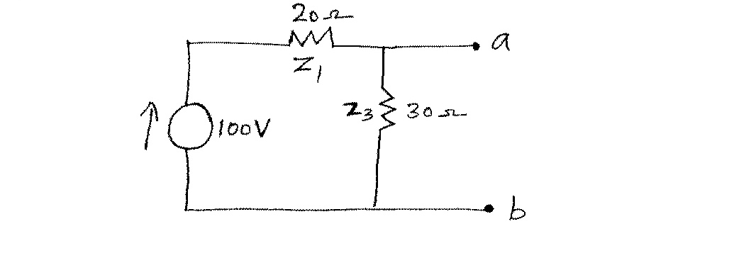
[P.T.O.]
SECTION C — (3 × 10 = 30 marks)
Answer any THREE questions.
20. A charged capacitor of capacitance C discharges through an inductor L and resistance R in an L C R circuit. Find an expression for the charge on the capacitor at any instant of time t. Find the frequency of the oscillatory discharge when R is small.
21. Describe the construction and working of a transformer..
22. Describe a magnetometer method of tracing the hysteresis curve for a sample of rod in the form of a long thin rod.
23. Give the construction and working of moving coil ballistic galvanometers. Obtain an expression for the quantity of electricity flowing through it. Apply the damping correction.
24. Explain with neat circuit diagram the experimental determination of mutual inductance.

———————

