**B.Sc. DEGREE EXAMINATION, APRIL 2017.**

**III YEAR — V SEMESTER**

**Major Paper XII — GRAPH THEORY**

**Time : 3 hours Max. Marks : 75**

**SECTION A — (10 × 2 = 20 marks)**

**Answer any *TEN* questions**

1. When two graphs are said to be isomorphic?
2. Define cut vertex and cut edge.
3. Define Hamiltonian cycle in a graph.
4. How the weight of a path is calculated?
5. Define “TREE” and “ leafnode “
6. Define Bipartite graph.
7. When a graph is called planner graph?
8. Define Dual graph.
9. What is proper colouring in graph theory?
10. What is Chromatic number χ(G)?
11. When a graph is said to be regular?
12. Define subgraphs.

**SECTION B — (5 × 5 = 25 marks)**

**Answer any *FIVE* questions**

1. Prove that “A graph G with n vertices, n−1 edges and no cycles is connected.”
2. A connected graph G is an Euler graph if and only if all vertices of G are of even degree.
3. If G is bipartite, then χ’ (G) =Δ(G).
4. Every connected graph has atleast one spanning tree.
5. Prove that “If a graph (connected or disconnected) has exactly two vertices of odd degree, there must be a path joined by these two vertices.”
6. Prove that “A tree with n vertices has n−1 edges.”
7. State and prove Euler’s formula for graphs.

**SECTION C — (3 × 10 = 30 marks)**

**Answer any *THREE* questions**

1. Check whether the graphs given are isomorphic or not

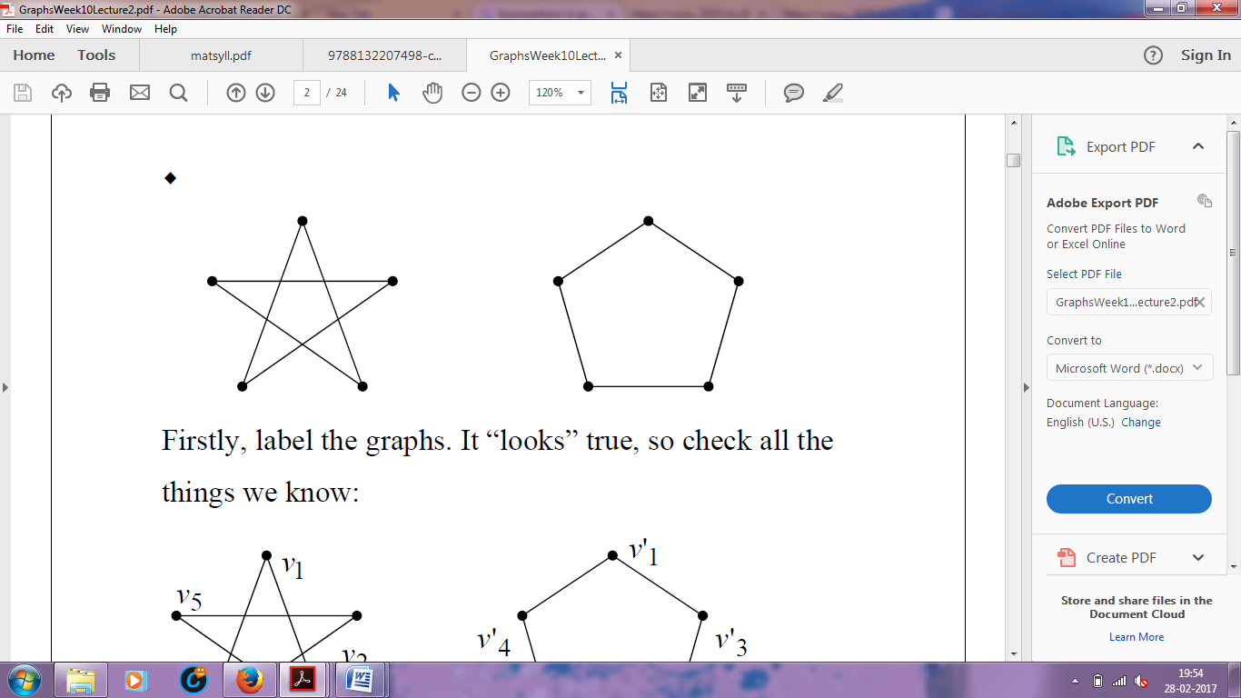

1. Prove that A connected graph has an Euler trail if and only if it has atmost two vertices of odd degree.
2. State and prove Hall’s Theorem.
3. Prove that A graph G is planar if, and only if, G contains no subgraph homeomorphic with K5 or K3 , 3 .
4. Prove that “Every planar graph is 5-colorable.5”

**­­­­­­__________**